# UKSPF Green Business Grants (Round 3 Extension) Guidance Document

# **Summary**

The Green Business Grant is designed to help small and medium enterprises (SMEs) and eligible sole traders purchase and install new products and equipment that reduce their greenhouse gas emissions, cut utility costs, and improve energy efficiency. The Green Business Grants were formally known as the Net Zero Business Grants.

Any eligible business can also request, subject to availability, a free carbon survey to identify energy efficiency improvements and potential energy reductions, helping to lower the business's overall carbon emissions. A business is not obliged to apply for a grant following a carbon survey, but please note that a valid carbon survey is required to apply for a large (£5,000 - £10,000) capital grant - see below for more information. Capital funding, in the context of this grant, refers to funding allocated for infrastructure development directly associated with the specific business premises it supports.

If you have any questions about Green Business Grants, you can email us at [climate.emergency@n-somerset.gov.uk](mailto:climate.emergency@n-somerset.gov.uk) with your query and contact details.

This is the third round (extension) of the UKSPF Green Business Grants Programme.

There are 3 opportunities in this funding programme:

1. **Business Carbon Surveys:** A carbon survey provides a tailored guide to help businesses identify energy inefficiencies, reduce energy consumption, and lower carbon emissions. It supports cost savings, environmental responsibility, and eligibility for grants or sustainability initiatives.

Any eligible SME or sole trader can apply for a survey however they will be provided on a first come first serve basis as we have finite funding available for the surveys. There is no obligation to apply for a grant following the survey being completed. While a carbon survey is not required to apply for a small capital grant, businesses can still choose to have one conducted. However, a valid carbon survey is mandatory to apply for large capital grants. Note that businesses are not obliged to apply for any grant funding after completing a survey. Applications for the carbon surveys are open now and will be first come first serve.

**2. Small Capital Grants:** Small grants range from a minimum of £500 to a maximum of £4,999. A carbon survey is not required to apply. Any eligible SME or sole trader can apply for a small capital grant. The total project cost must be outlined. Applications must include a completed form and accompanying quotes. Match funding is not required but will be viewed favourably. The application period opens on 01 March 2025 and closes on 31 May 2025.

3. **Large Capital Grants:** Large grants range from £5,000 to £10,000. Match funding is not required but will be viewed favourably. Any eligible SME can apply for a large capital grant, but sole traders are not eligible to apply. The total project cost must be outlined, and match funding can be used to cover additional project expenses. A valid carbon survey is required. Applications must include a completed form and quotes. The application window opens on 01 May 2025 and closes on 30 June 2025.

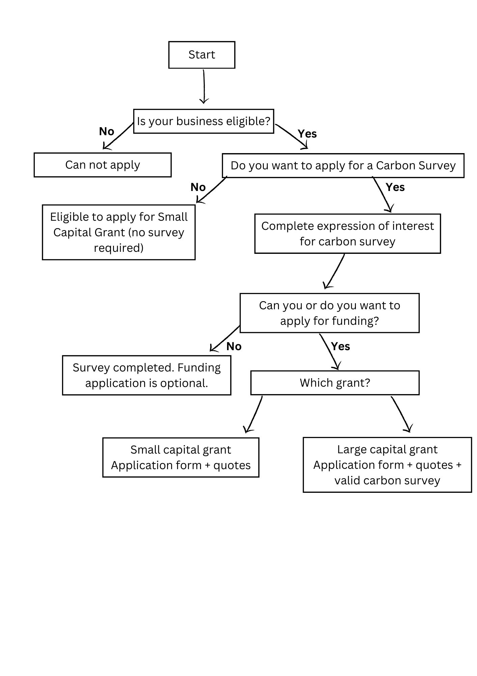

Process Flowchart for UKSPF Green Business Grant Applications

# **Eligibility**

The following eligibility criteria apply to all sections of the grant funding:

* You are EITHER a small or medium sized enterprise–fewer than 250 employees AND a turnover of equal to or less than £36 million OR a balance sheet of equal to or less than £18 million, including any partnership your organisation is a part of or any linked enterprises; OR you are a sole trader - a self-employed individual who owns and runs a business, and does not employ any additional employees (other than themselves);
* you are a registered business whose trading address is in North Somerset <https://www.gov.uk/find-local-council>
* you are a UK taxpayer who can supply a valid UTR number;
* you will use the grant for an existing building structure where energy efficiency improvements have been identified – the grants are not applicable to new buildings or structures;
* you can provide evidence of the needed improvements. Large grant applications must provide evidence of the improvements through a carbon survey, while small grant applications can be self-evidenced (e.g., through energy bills, energy inefficient equipment, heat loss or air leaks, and poor lighting efficiency);
* your total project cost will not exceed the stated total project costs for each grant, (£10,000 for the small capital grants and £20,000 for the large capital grants);
* you have not received more than £315,000 of grants in the last three financial years;
* you have at least 1 year remaining on your lease or rental agreement, if relevant;
* you have written landlord permission to conduct any works, if applicable;
* the building where you want to carry out improvements meets current Building Regulations, where relevant;
* you have planning permission, if required;
* you can cash-flow your project so you can purchase what you need before claiming your grant funding;
* you have not started any works, or entered into any contract, relating to your grant expenditure.

**Who is not eligible to apply?**

The following businesses are not eligible to apply:

* large businesses, partnerships, and businesses using cash-based accounting;
* franchises or smaller business units part of a larger parent company structure;
* religious institutions;
* schools, colleges and universities GPs, dentists, care homes, and publicly funded services;
* Charities or community interest companies;
* private domestic landlords or businesses operating from buildings that are required by law to have a domestic Energy Performance Certificate;
* Applicants or organisations that are in administration, that are bankrupt or going through bankruptcy proceedings, that are insolvent, or for whom a striking off notice has been made.

### **What can’t the grant be used for?**

The grant cannot be used for:

* anything not recommended by a suitable independent assessment of your business’ carbon emissions (large grants only);
* anything that does not meet the requirements of this grant guidance;
* improvements that do not directly result in carbon savings, such as water saving systems;
* retrospective applications for completed projects or those where a contract/commitment has been entered into with suppliers;
* improvements that cost more than the total eligible project cost (ex VAT) in total;
* improvements to buildings that are required by law to have a domestic energy performance certificate;
* activities which are part of a new build or extension, the project must be improving existing buildings which your business currently operates from;
* activities that you are required by law to carry out, such as to meet a condition of planning permission or minimum energy efficiency standards;
* revenue (non-capital) costs such as surveys, consultancy, planning fees or improvements such as migration to cloud or remote services;
* projects that do not align with the core values of this funding, especially those involved in (or potentially involved in) the following activities:
  + environmental harm;
  + exploitation;
  + discrimination or inequality;
  + animal cruelty;
  + tobacco, alcohol or gambling;
  + weapons or military development;
  + fraudulent activities.

# **Small Capital Grants**

### **Grant Overview**

The Small Capital Grant Programme is helping small and medium-sized enterprises (SMEs) and sole traders in their journey toward decarbonisation by providing financial support for energy efficient and carbon-reducing technologies. The grant value is ranging from £500 to £4,999.99. By targeting technologies with proven benefits, the initiative helps businesses lower energy consumption, cut operational costs, and reduce carbon footprints. Capital funding, in the context of this grant, refers to funding allocated for infrastructure development directly associated with the specific business premises it supports.

Benefits include:

* Reduced energy bills through enhanced efficiency.
* Decreased carbon emissions in line with sustainability goals.
* Enhanced environmental credentials for your business.

### **Eligible Technologies**

The grant can be used for projects that involve the purchase and installation of the following:

* Cavity Wall, Loft or Floor Insulation
* LED Lighting
* Lighting Controls
* Pipe, Flange, Valve, and Boiler Room Component Insulation
* Automated Door Systems
* Voltage Optimisation
* EV Charging point
* Energy efficient cooking equipment
* Energy efficient appliances

This list is not exhaustive, and we are open to other ideas. Please contact [climate.emergency@n-somerset.gov.uk](mailto:climate.emergency@n-somerset.gov.uk) to discuss your proposal and to ensure that it is eligible.

### **Funding Details**

* Small grants are available for SMEs and sole traders located within North Somerset.
* Funding covers the technologies and direct installation costs, but not additional structural surveys or costs associated with permissions etc.
* Total project costs must not exceed the total eligible project cost (ex VAT).

### **Application Process**

**Step 1: Eligibility Check**. Ensure your project and your business aligns with the programme's objectives and eligible technologies.

**Step 2: Get a quote**. Your application will need to include a recent quote for the work proposed in the grant application.

**Step 3: Application submission.** Complete the application process including gathering and submitting the following:

* + Quotes for proposed energy efficiency measures
  + Roof structural survey (if applicable)
  + Landlord permission (if applicable)
  + Confirmation of planning permission required (if applicable)
  + Application form

**Step 4: Application assessment.** Applications will be assessed after the deadline closes at the end of May, with funding awarded to projects that have best evidenced energy , and the potential impact on their business.

The application process will open **01 March** and will close on **31 May 2025.** Please send completed applications to [climate.emergency@n-somerset.gov.uk](mailto:climate.emergency@n-somerset.gov.uk).

# **Large Capital Grants**

### **Overview**

The Large Capital Grant Programme provides financial support for small and medium-sized enterprises (SMEs) looking to implement more substantial decarbonisation projects. With grant values ranging from £5,000 to £10,000, this programme enables businesses to undertake impactful projects that significantly reduce carbon emissions and energy consumption. Sole traders are not eligible to apply for the large capital grants funding.

This programme is tailored for SMEs committed to achieving meaningful energy savings through larger-scale decarbonisation initiatives. By focusing on projects such as solar PV systems and air source heat pumps, the grants aim to drive sustainable transformation and align businesses with the council and the UK's net-zero goals.

Benefits include:

* Reduced energy bills through enhanced efficiency.
* Decreased carbon emissions in line with sustainability goals.
* Enhanced environmental credentials for your business.

### **Eligibility Criteria**

To qualify for the grant, businesses must meet the following requirements:

* Obtain a carbon survey report carried out by an independent third party.
* The survey must quantify carbon saving recommendations and have been completed within the last three years (no earlier than January 2022).
* For businesses with multiple locations, the survey must specifically address the relevant premises.
* Secure a detailed quote for the measures you are applying for.
* Ensure all structural work and permissions requirements are satisfied:
* If applying for solar panels, provide a roof structural survey.
* Obtain written landlord permission, where relevant.
* Ensure compliance with current Building Regulations and any necessary planning permissions (including permitted development).
* The grant request must be between £5,000 and £10,000. Match funding is not required but is favourable for your project as we will be assessing value for money based on energy and carbon savings.
* Ensure the project can be completed within funding timescales (before March 2026).

### **Eligible Technologies**

Funding supports a range of decarbonisation technologies, including but not limited to:

* Solar PV Panels
* Air Source Heat Pumps
* Other Large-Scale Energy Efficiency Measures: Projects identified in the carbon survey with substantial carbon savings.

### **Application Process**

**Step 1: Obtain a carbon survey report.** This must fit the acceptable criteria and format for eligibility.

**Step 2: Eligibility check**. Ensure your project and your business aligns with the programme's objectives and eligible technologies.

**Step 3: Get a quote**. Your application will need to include a recent quote for the work proposed in the grant application.

**Step 4: Application submission.** Complete the application process including gathering and submitting the following:

* + Carbon survey report
  + Quotes for proposed energy efficiency measures
  + Roof structural survey (if applicable)
  + Landlord permission (if applicable)
  + Confirmation of planning permission required (if applicable)
  + Application form

**Step 5: Application assessment.** Applications will be assessed after the deadline closes in May, with funding awarded to projects that have best evidenced energy and carbon savings, and alignment with the programme’s objectives.

### **Funding Details**

Projects must demonstrate clear carbon and energy reduction benefits and align with the recommendations of the carbon survey.

### **Timeline**

Applications will open from 01 May 2025 and will close on 30 June 2025.

**Carbon Surveys**

The Council is offering a limited number of free carbon surveys, which will be carried out by Future Leap, to small and medium-sized enterprises (SMEs) as part of its commitment to supporting local businesses in reducing their environmental impact. These surveys provide businesses with valuable insights into their carbon footprint and practical recommendations for implementing energy-efficient and renewable solutions.

We have partnered with Future Leap again to deliver the carbon surveys, to find out more about the sustainability services that Future Leap offer please see their website:

<https://futureleap.co.uk/consultancy/>

### **Benefits of the Survey**

By having a carbon survey completed, businesses will:

* Gain a detailed understanding of their current carbon emissions.
* Receive tailored advice on actionable steps to reduce energy consumption and carbon emissions.
* Become eligible to apply for a large capital grant of between £5,000 and £10,000 to implement recommended energy efficiency measures.

**Please note that carbon surveys conducted by other providers are also accepted as part of the large capital grant application process.**

### **How to Apply**

* Step 1: Register your interest in receiving a carbon survey using the following link <https://forms.office.com/e/kibXrBYyqY>
* Step 2: If you successfully qualify for a carbon survey, you will need to coordinate with our partners at Future Leap to arrange a site visit and share information such as energy bills.

### **Why Participate?**

The Free Carbon Surveys programme offers businesses an exceptional opportunity to assess and improve their sustainability practices at no cost. By participating, SMEs can:

* Reduce energy expenses and improve operational efficiency.
* Strengthen their environmental credentials to attract eco-conscious customers.
* Access substantial financial support to implement sustainable solutions.

**Frequently Asked Questions**

**How is the Green Business Grant programme funded?**

The programme is funded by UK Shared Prosperity Fund (UKSPF), which succeeds the old EU structural funds. This money aim to support local places across England, Scotland, Wales and Northern Ireland to invest in three local priorities: communities and place, support for local businesses, and people and skills. More information can be found here UK Shared Prosperity Fund: prospectus - GOV.UK ([www.gov.uk](https://www.gov.uk)).

**Can I apply for both grants?**

No, you can only apply for either the large grant or small grant and only one application is allowed.

**How many times can I apply for the grant?**

You can apply for a small grant or a large grant once. Multiple applications for the same business will not be accepted.

**How many carbon surveys can I apply for?**

Each business is only eligible to apply for one carbon survey.

**I have a carbon survey from the previous UKSPF funding round. Can I use it to apply for a capital grant this time?**

Yes, if your carbon survey was completed during the previous round of this grant funding, it can be used to apply for capital funding in this round. However, the survey must have been conducted on or after 01 January 2022 to be eligible to apply for the grant.

**Can I apply if I have applied for other grants in the council before?**

We would welcome applications from businesses who have applied for grants through the council before. If your business has applied for a UKSPF Green Business Grant before, the new application should be for a new project and should not be an extension of a project which has been previously funded through the programme (e.g. to complete an unfinished previously funded project).

**When should the project be complete?**

You must be able to complete your project by 1 March 2026.

**I cannot complete my application by the stated deadlines, can I have an extension to my application?**

Unfortunately, due to the popularity and time constraints of this grant programme, all applications must be submitted by the specified deadline.

**I am not sure if my business is eligible for the funding programme?**

If after reading this guidance you still have any questions about eligibility, please contact the grant support team at [climate.emergency@n-somerset.gov.uk](mailto:climate.emergency@n-somerset.gov.uk)

**I work from home, or my office is based at my home. Am I eligible to apply for this funding?**

To qualify for this funding, your business address and premises must be entirely separate from your home address. This ensures accurate assessment of energy savings and costs specific to your business operations, as combined energy bills for home and business cannot be quantified effectively.

**What should I do if I have trouble completing the application?**

If you need assistance, please contact the grant support team at [climate.emergency@n-somerset.gov.uk](mailto:climate.emergency@n-somerset.gov.uk), and we will be happy to help guide you through the application process.

**What happens if I don't use the grant money for the intended project?**

If it is discovered that the grant funds were not used for the intended project, you will be legally required to repay the grant and may be disqualified from future funding opportunities. However, payment of the grant will only be approved once evidence has been submitted of the completed project.

**Can the grant be used for projects already underway?**

Grants are intended for new projects or those in the planning phase. If your project is already completed or significantly advanced, it will not be eligible for funding.

**How long does it take to hear back about my application?**

We will aim to notify you of the outcome within 6-8 weeks after the application deadline.

**What happens if my application is unsuccessful?**

If your application is not successful, you will have the opportunity to ask us for feedback on the reasons for the decision. You may be able to reapply for future funding opportunities.

**Do I need to provide progress reports once I receive the grant?**

Yes, successful applicants will be required to submit quarterly progress reports, including evidence of how the grant is being used for the intended project and the benefits it has brought to your business.

**Can I appeal the decision if my application is rejected?**

Unfortunately, decisions are final, but you can contact the grant administrators for feedback and advice on improving future applications.

**Can I use the grant for ongoing maintenance or operational costs?**

Grants are intended for capital improvements, not for operational or maintenance costs. Ensure your project focuses on one-time upgrades or enhancements related to energy efficiency.

**What happens if my grant application is successful, but we are then unable to fulfil the project?**

If this happens, please contact the grant support team as soon as possible at [climate.emergency@n-somerset.gov.uk](mailto:climate.emergency@n-somerset.gov.uk)

**If my application is successful, how will the money be paid to me?**

Claims will be processed in arrears on the receipt of a paid invoice or receipt for the work being carried out on your business.

**What happens if I don’t spend all the grant money?**

You will only be paid retrospectively for the work which has been carried out, as agreed in the funding application and subsequent grant offer letter.

If you have any further questions about the details in this document or the programme, please do not hesitate to contact the grant support team at [climate.emergency@n-somerset.gov.uk](mailto:climate.emergency@n-somerset.gov.uk)